Install IPython
From the top left menu, Open a terminal: Applications => System Tools => Terminal
Type:
sudo easy_install ipython==1.2.1
Hit enter, administrator password is cloudera.

Launch pyspark with IPython
Every time you need to open the pyspark shell, open a terminal and type:
PYSPARK_DRIVER_PYTHON=ipython pyspark
Hit enter, after the startup logs, you should see the pyspark console:
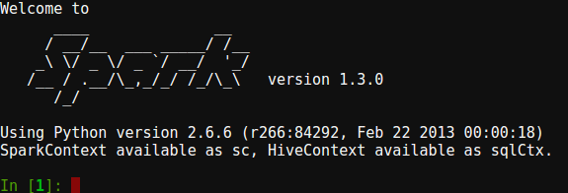

Check version
To make sure that PySpark started correctly, print out the version by typing in the PySpark IPython terminal:
sc.version
Verify that the output is:
u'1.3.0'

